**IA – 2 (SET C)**

**TITLE – Language Learn**

|  |  |
| --- | --- |
| **Name: Prachi Gandhi** | **Roll No.: 16010422233** |
| **Name: Chandana Galgali** | **Roll No.: 16010422234** |

**Problem statement:**

A language-learning app that uses gamification to make learning fun and engaging. Features include gamified lessons, daily streaks, points, badges, and leaderboards.

**Abstract: (Describe what exactly have you covered in the IA)**

The paper presents the design for a mobile application "Language Learning" and showcases user engagement through gamification and an extremely smooth and intuitive interface. The various UI screens shall be designed using Figma in high fidelity by incorporating very fundamental patterns for page composition and component management to enhance the user experience. This design includes an app annunciator row for device notifications, a revealable menu for easy navigation, an interstitial screen to track progress, and a vertical scroll to browse through the content on key screens. Further, the Home screen includes an interactive slide show that rotates daily learning content around "Word of the Day" and "Quick Challenge," meant to entice users every day for new language learning material. Each of these screens is rendered in two color combinations that are actually providing alternative views for getting an idea about the comparison of visual and functional effectiveness. This will provide an interactive and instructive app experience.

**Design minimum 5 Mobile UI Screens that covers the following:**

* **Should be a high fidelity design**
* **Attach screenshots of all the screens with two colour combinations and two alternative views of functionalities**
* **Clear flow of functionality must be visible**
* **With each screen, explain the pattern that has been used in the screen**

The app features five high-fidelity screens, each embodying specific Figma design patterns that align with the needs of mobile interface design:

**Page Composition (Anunciator Row) –** The top part of each screen houses an annunciator row, home for priority device information such as battery level, time, and network status. This convention helps ensure that at any point in time, users do not have to leave the app to know this information, hence enabling a smooth learning experience. Since this information is kept upfront on the device, the annunciator row improves usability and maintains user awareness of information even while studying their target language.

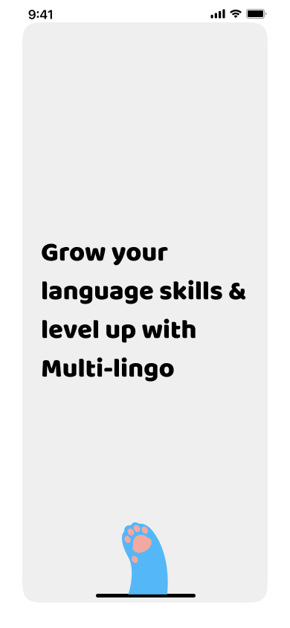The “Anunciator Row” at the top displaying time, WiFi strength and battery level.

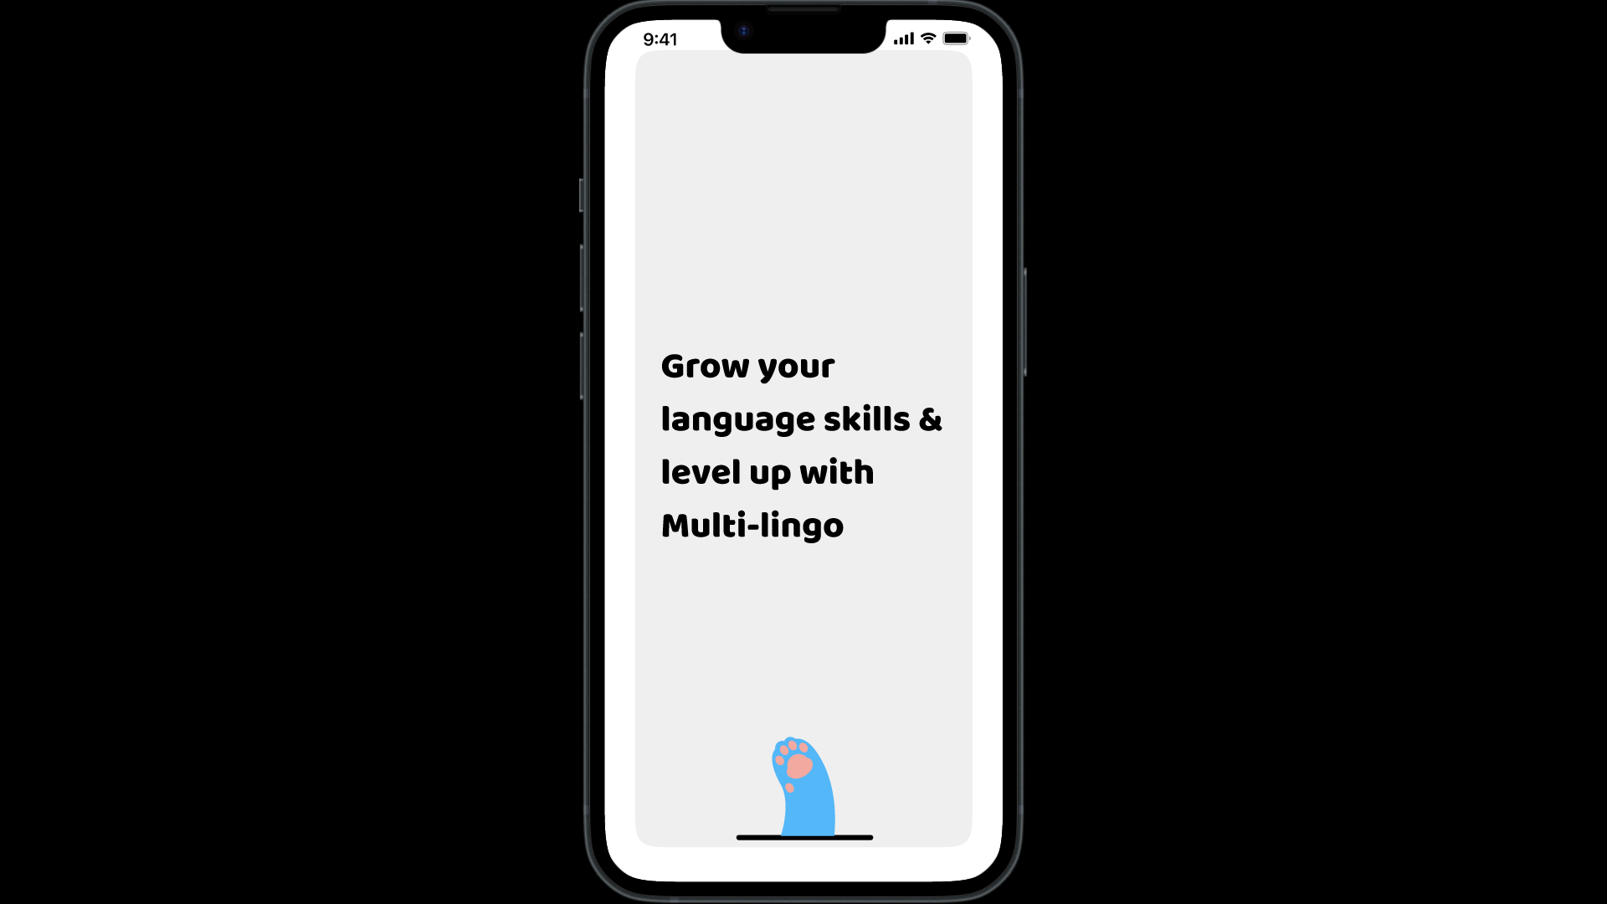

**Page Composition (Revealable Menu) –** The revealable menu, which can be opened by clicking on the hamburger icon, makes going to any section in the app easy. If the menu is triggered, then a list of categories would pop up, such as “Learn”, “Stories”, “Dictionary”, “Words”, “Podcasts”, “Shop”, “Chat”, “Study Groups”, “Discuss” and “Events”. This pattern enables the use of efficient navigation, whereby users can quickly move between sections without having to return to the main page, which protects the flow and accessibility of navigation.

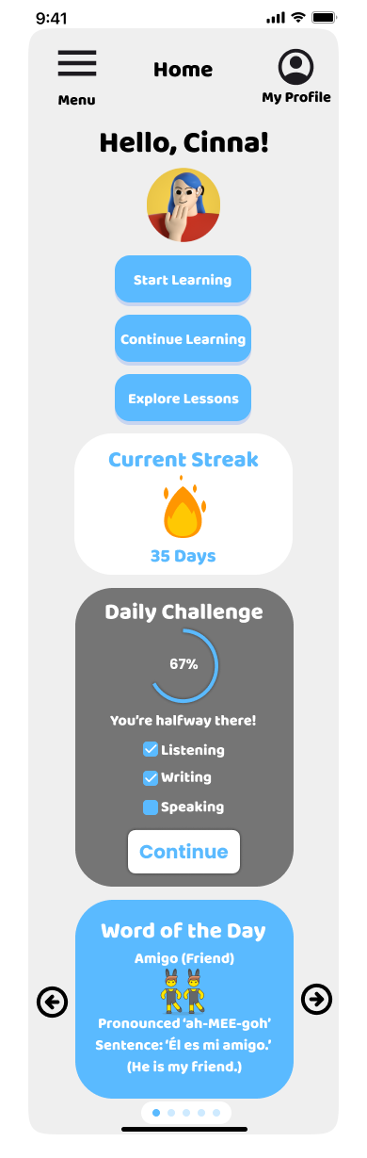

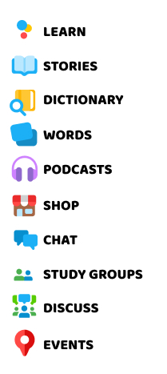

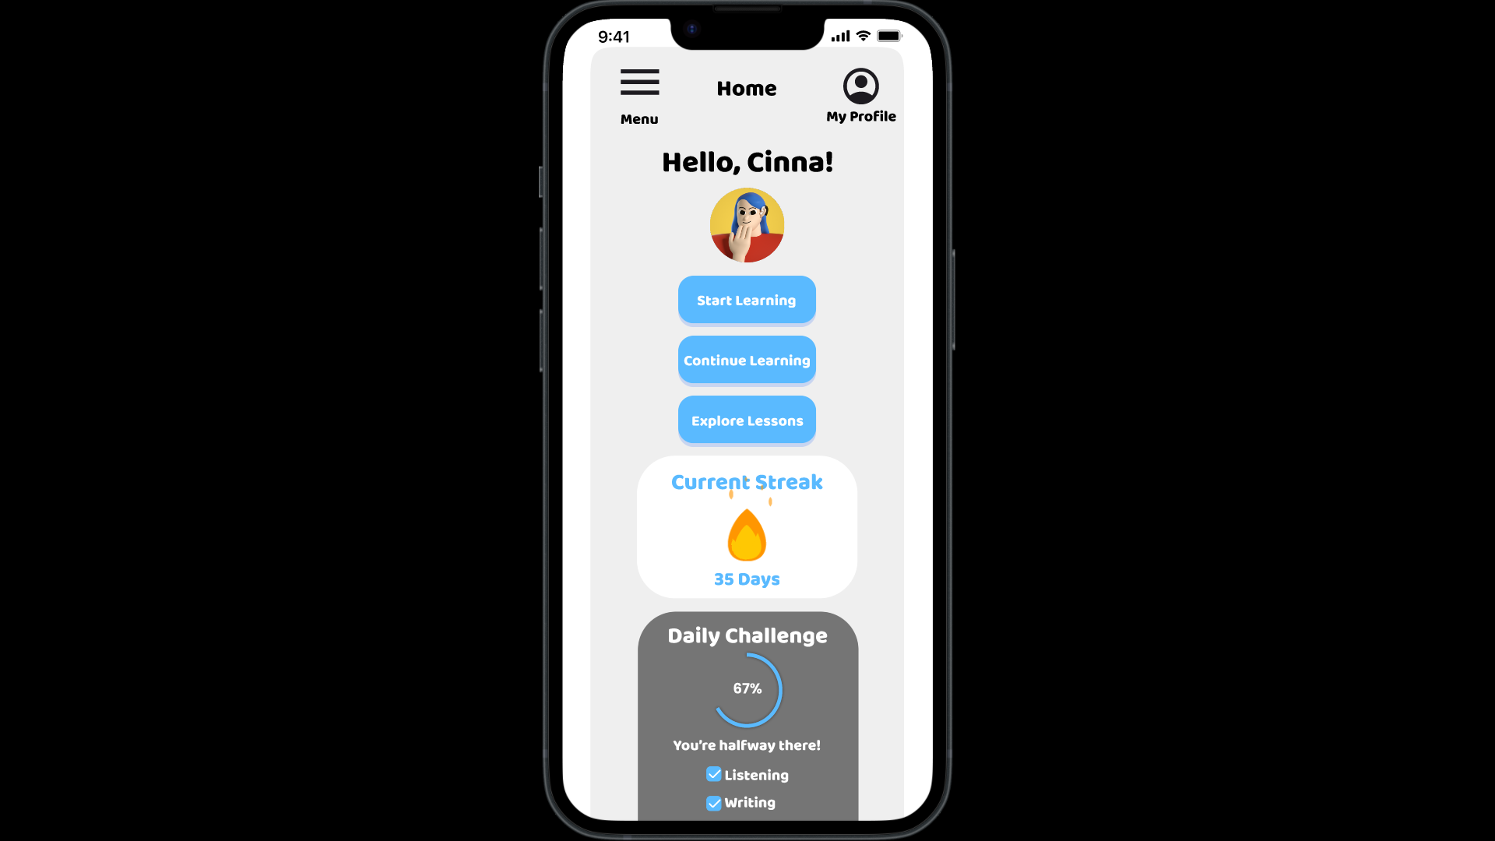

On clicking “Menu”, the navigation panel appears.

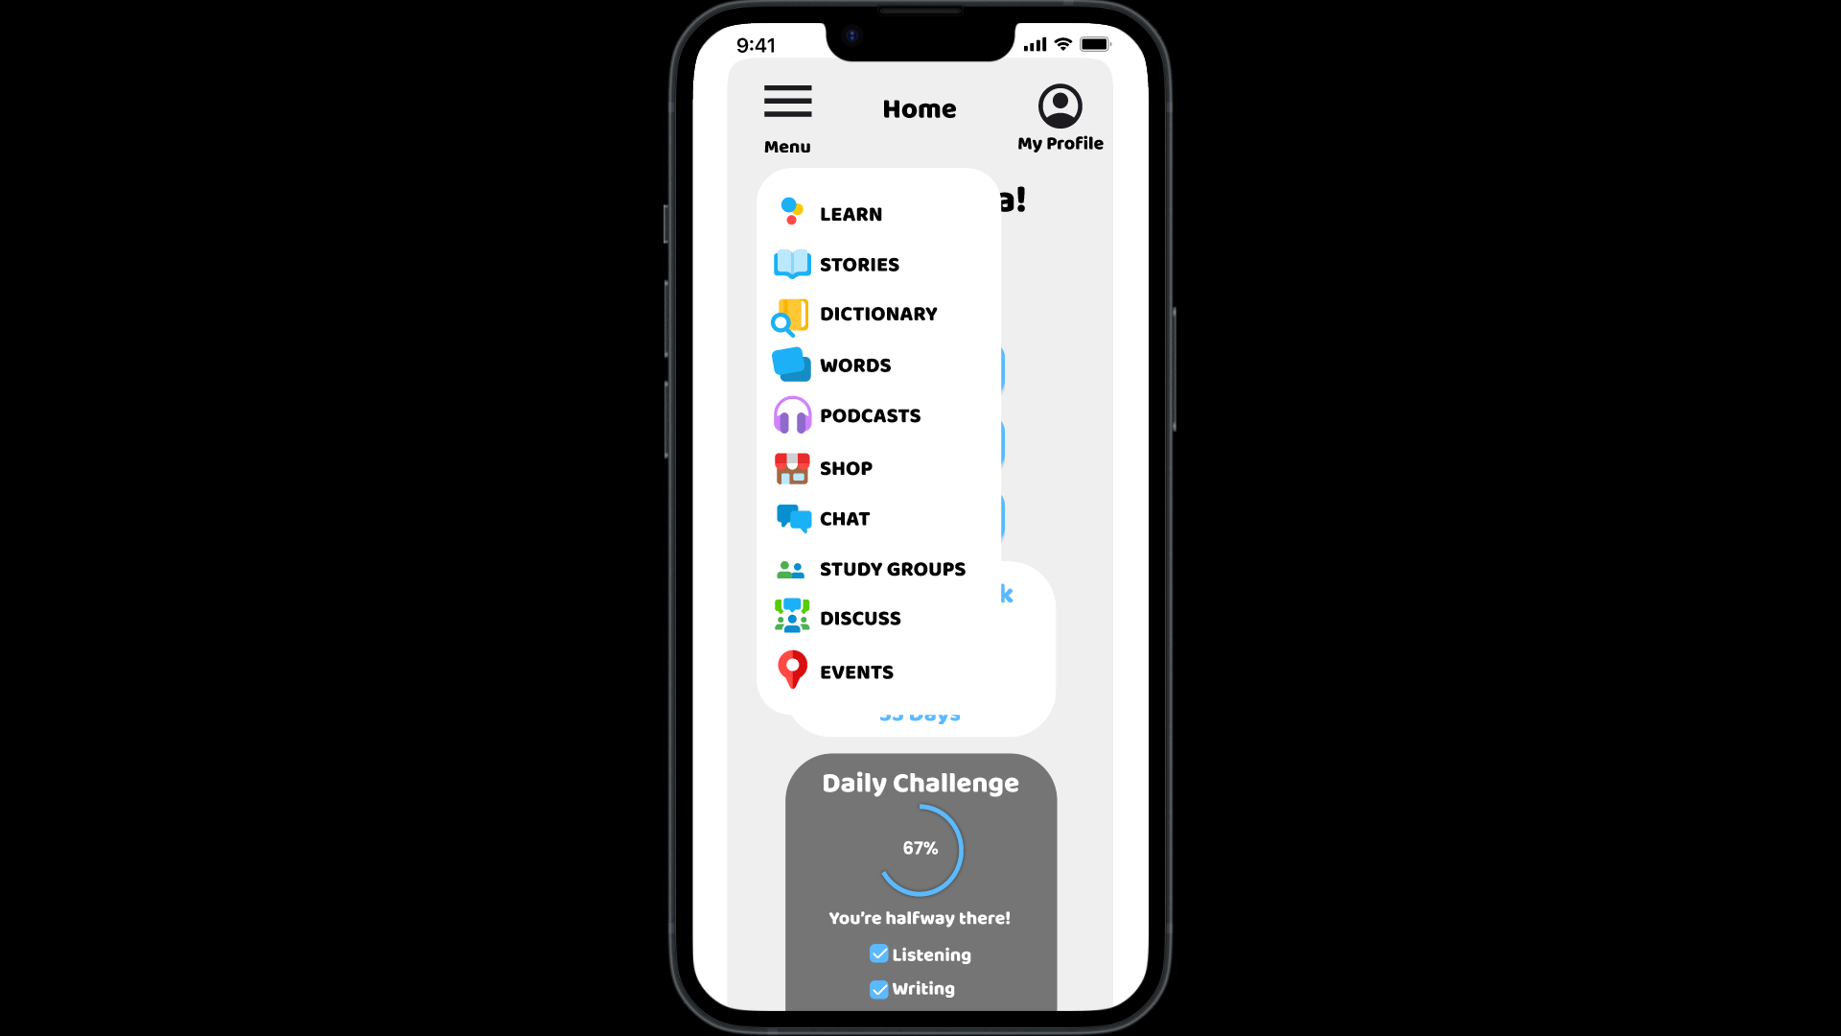

**Page Composition (Interstitial Screen) –** After the initial setup process, an interstitial screen shows to a user the progress of processing their responses. This is a brief pause for users to get informed about their progress, adding an element of gamified anticipation. After setup, the app will smoothly transition into the home screen, further enhancing the user's onboarding experience with impressions of accomplishment and tracking of progress.

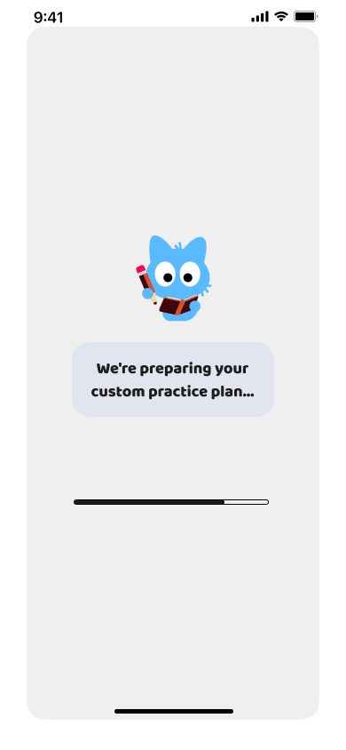





After completing the setup process, the following screen appears.

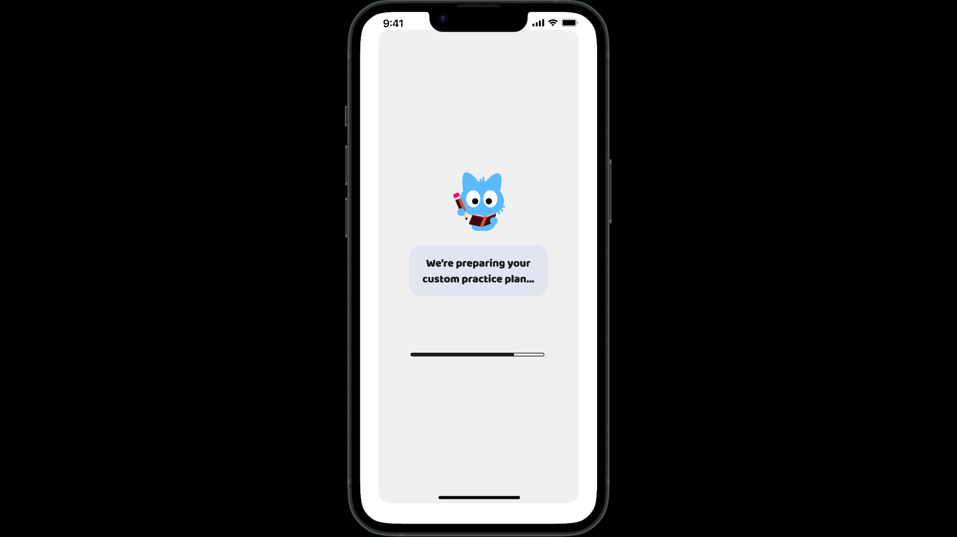

After a delay of 3000 ms, the user is notified of their progress in percentage as shown below to increase their anticipation.

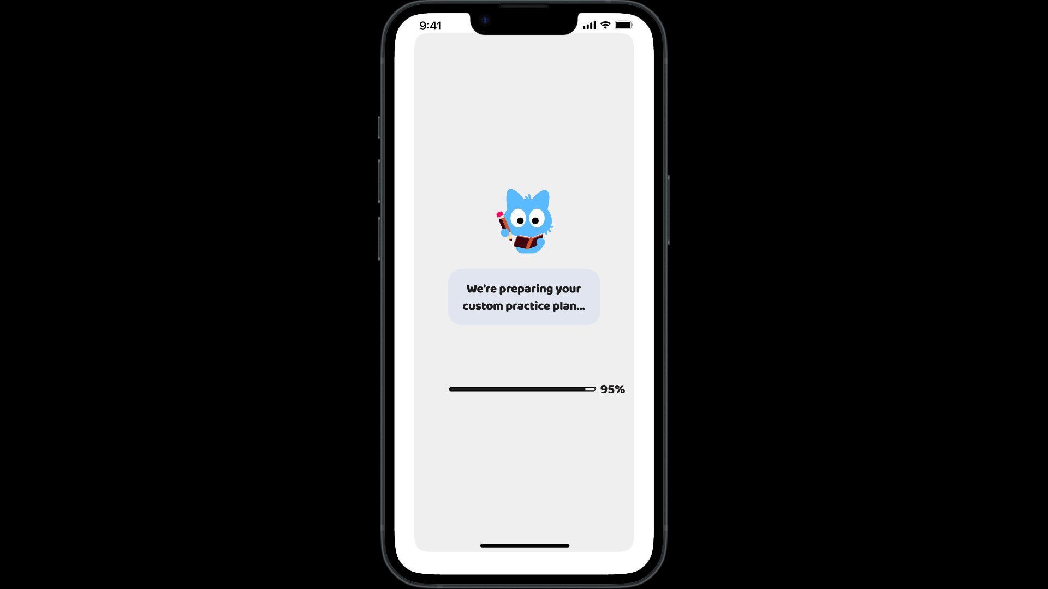

The user is then navigated to the home screen.

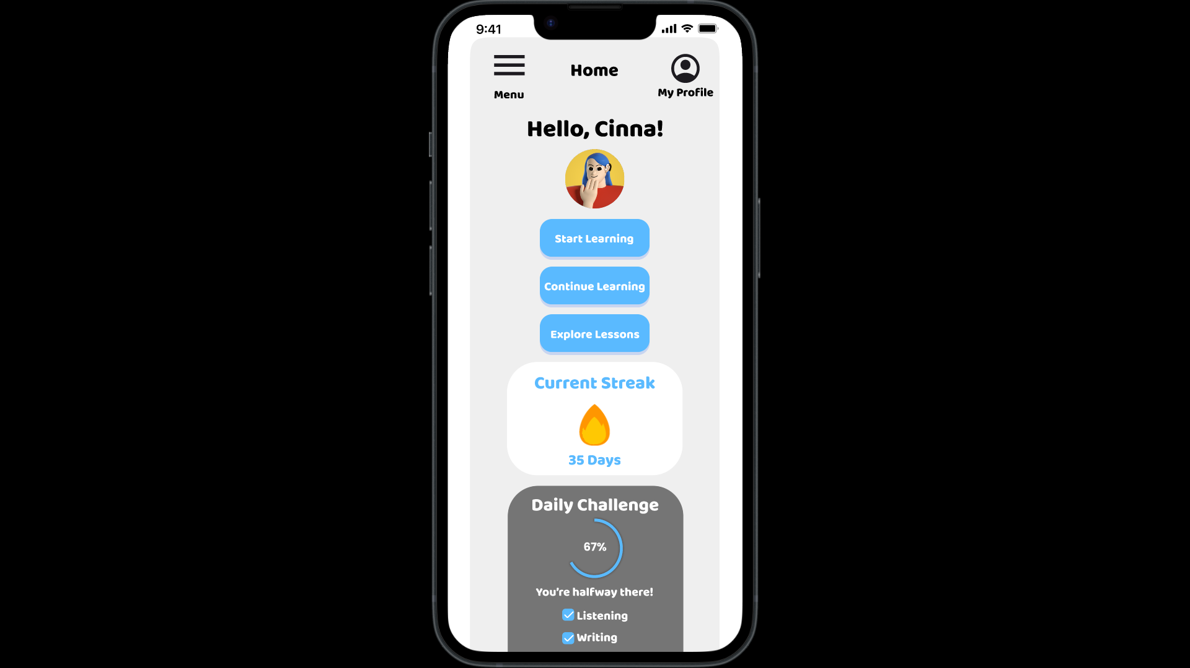

**Page Composition (Scroll) –** The Home and Dashboard screens pop up with a vertical scroll pattern, allowing the user to scroll to easily view different sections. This enables users to see, on the home screen, their current streak, daily challenge progress and an interesting slideshow to reinforce the learning experience. The Dashboard screen comprises scrolled content for leading the users through some selected courses they have chosen, leaderboards, view their friends who are online and words that they have added to their dictionary. There is also, in this pattern, a vertical scrolling that's natural and intuitive for users to navigate within each screen in order not to get buried by it when trying to visit all the key information.



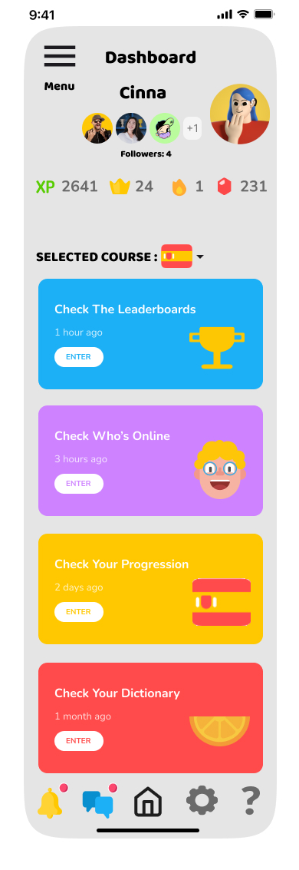

The Home Page incorporates the “Scroll” pattern as shown below.

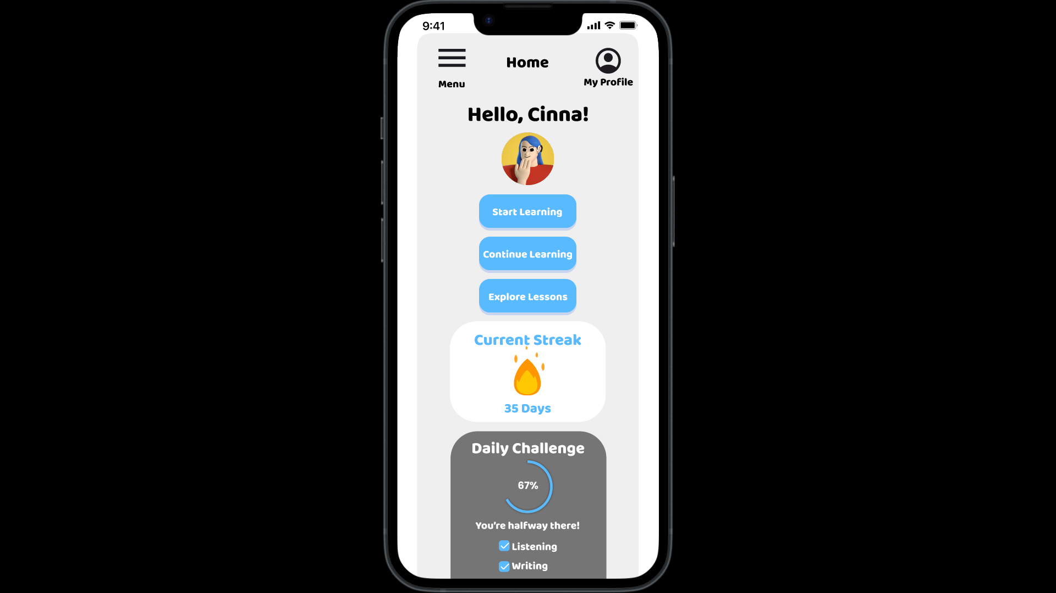

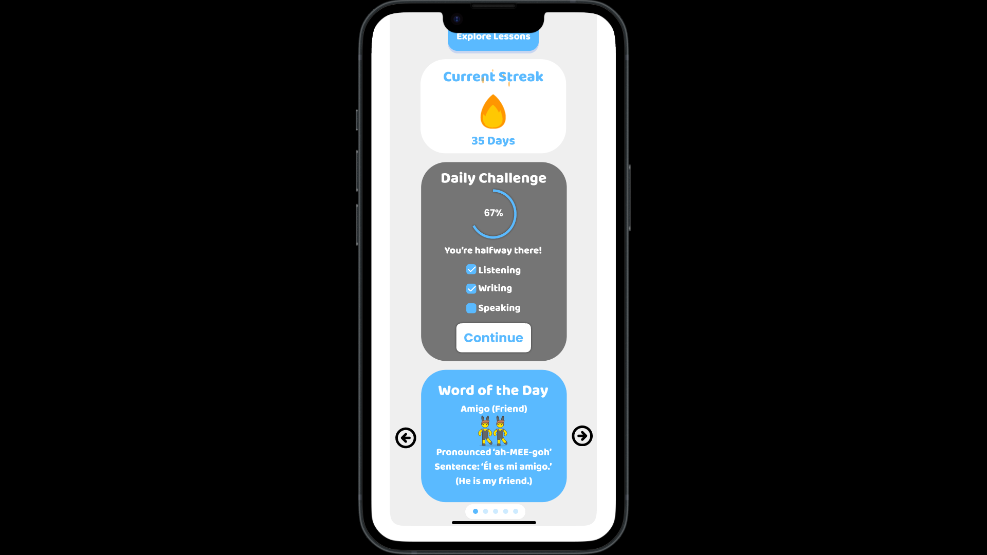

The Dashboard Page incorporates the “Scroll” pattern as shown below.

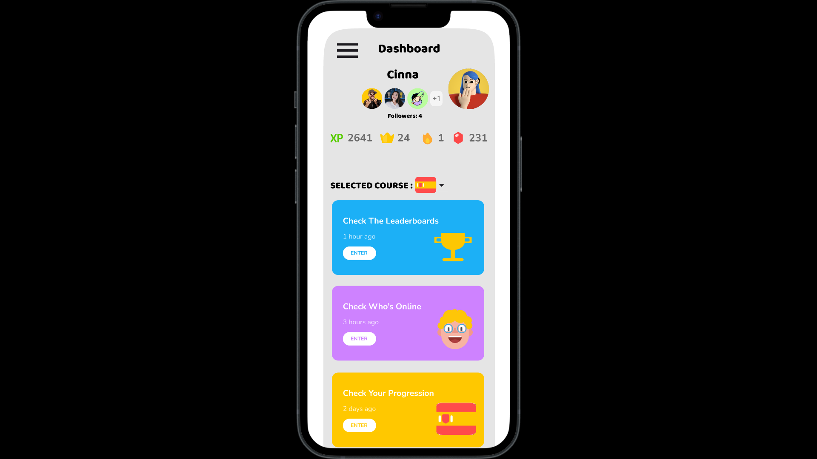

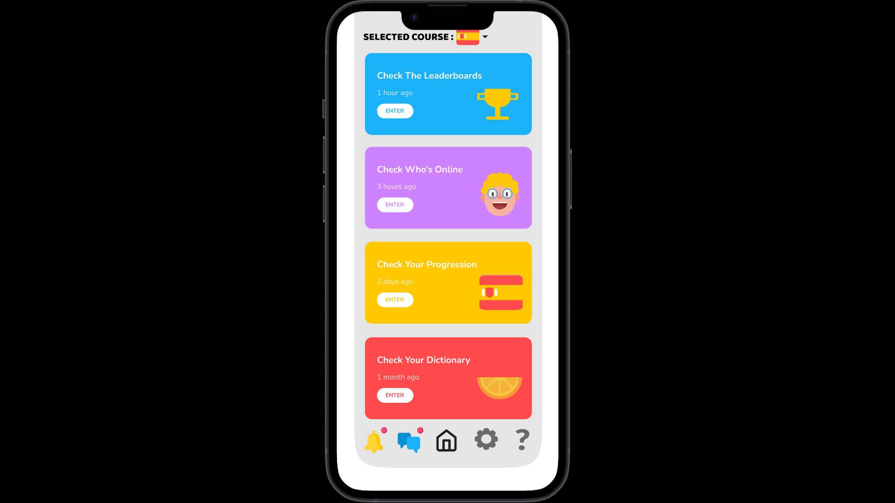

**Managing Mobile Component - Display of Information (Slideshow) –** Situated at the bottom of the Home screen, the slideshow offers richly interactive content that flows between “Word of the Day”, “Phrase of the Day”, “Fun Fact”, “Learning Tip” and “Quick Challenge”. Each slide can be skimmed through by the users for bite-sized content that will help them with language learning in a fun manner. This keeps knowledge fresh and fosters daily participation in an engaging manner. The active arrows allow the user to step through each piece of content at their own pace, reinforcing learning by adding an element of discovery.

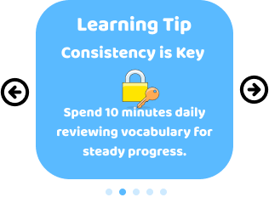

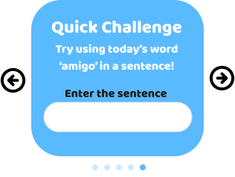

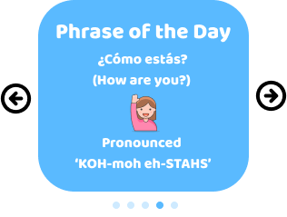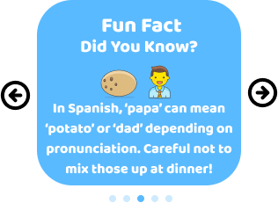

The slideshow at the bottom of the Home page. The right and the left arrows are functional and can be used to navigate back and forth between the slides.

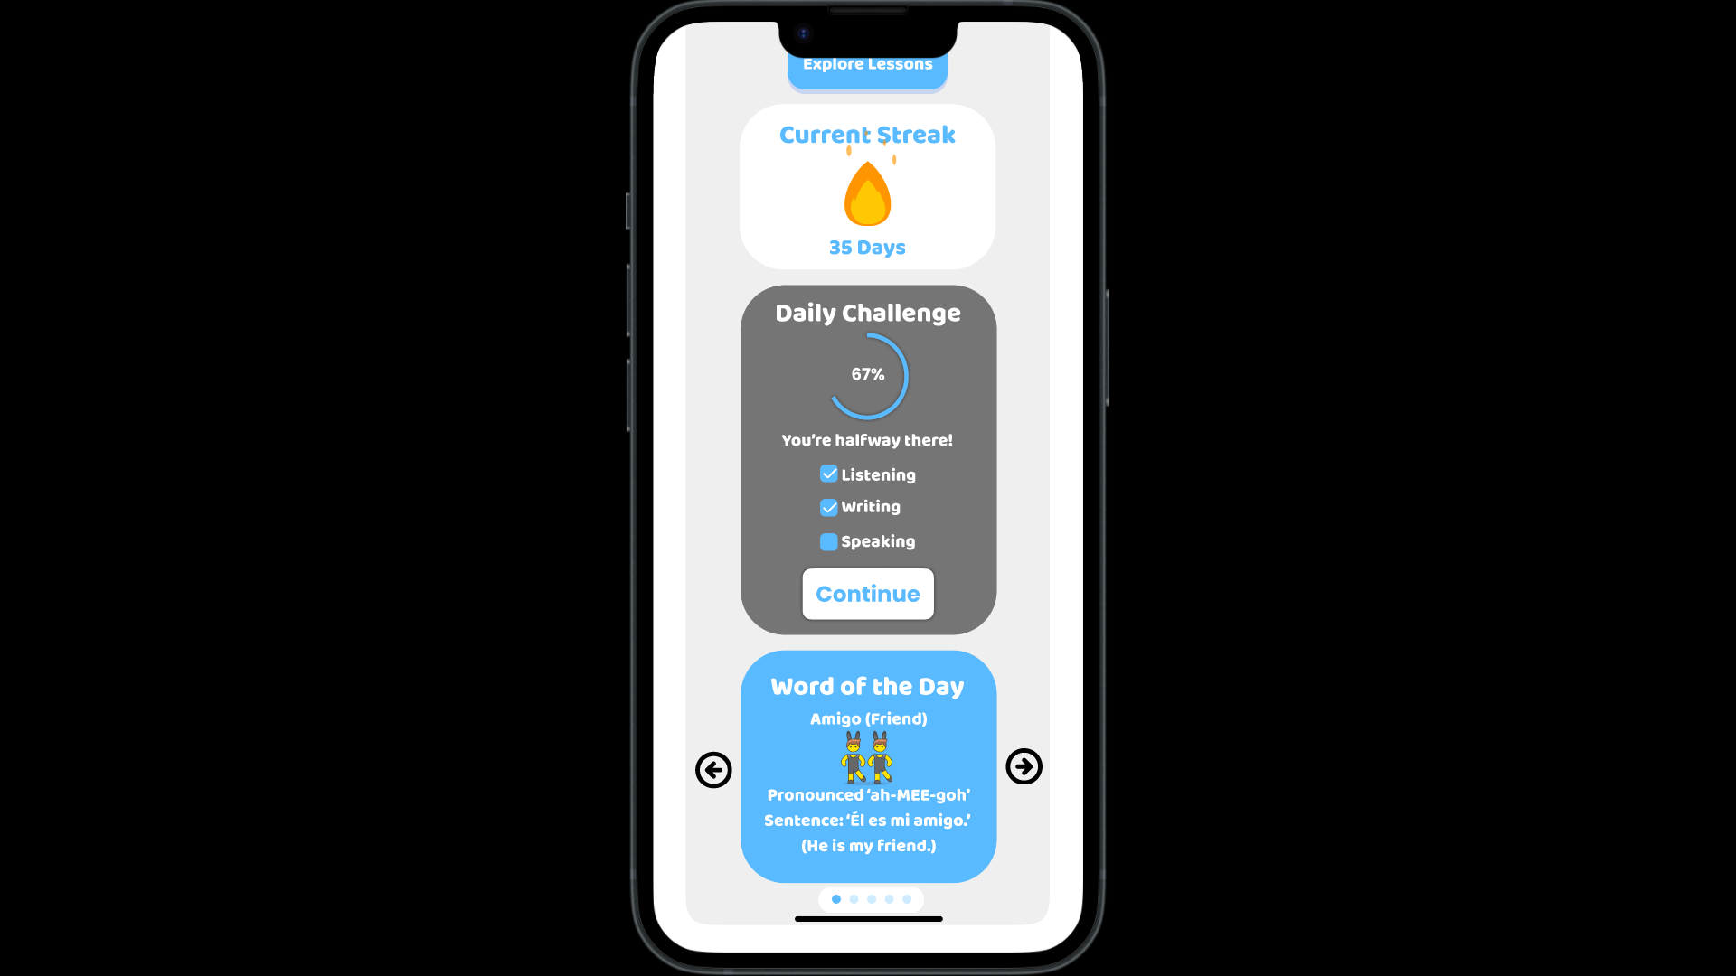

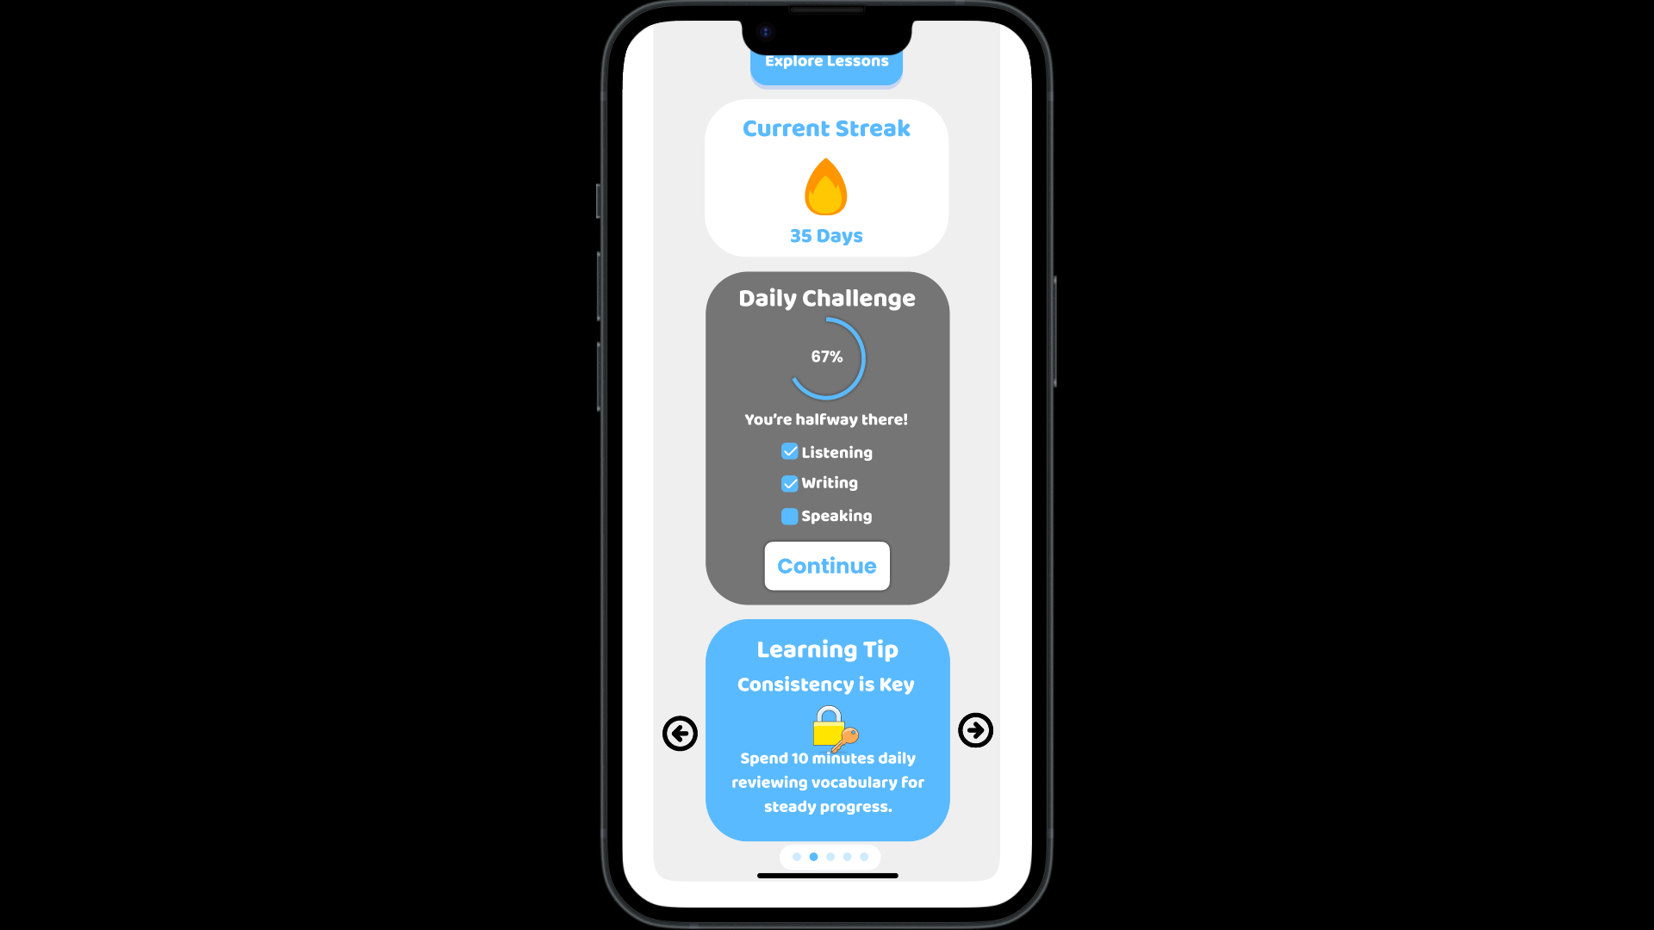

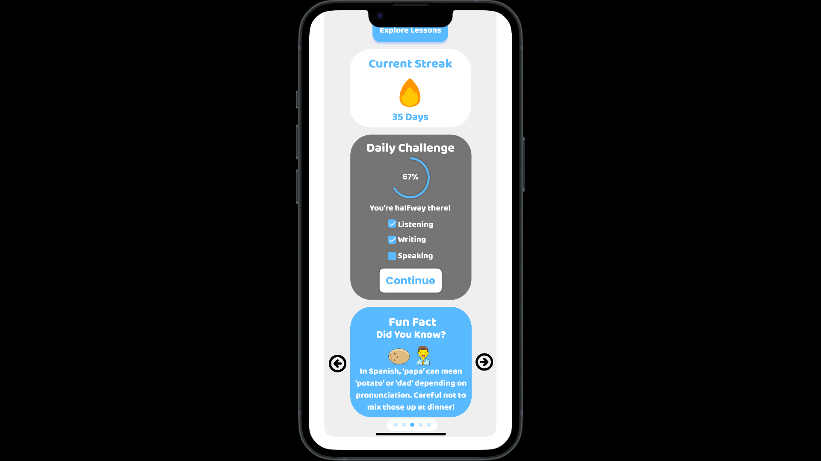

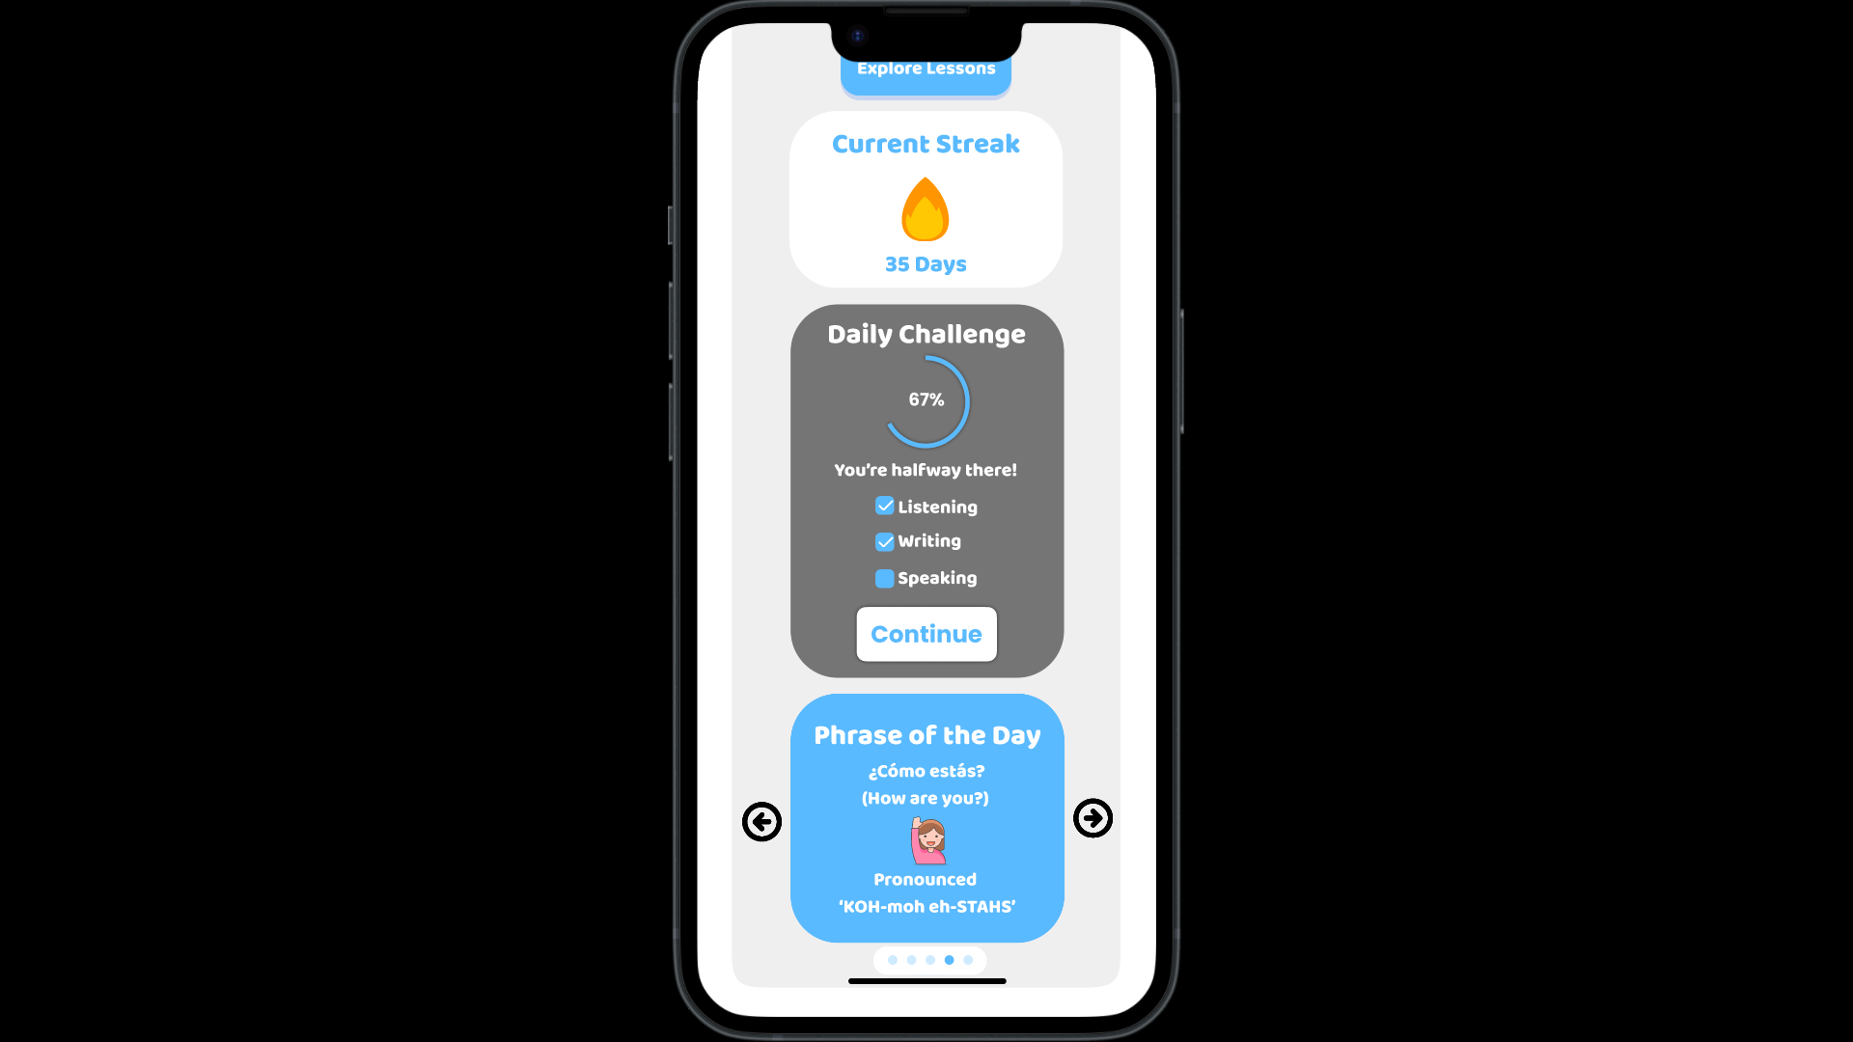

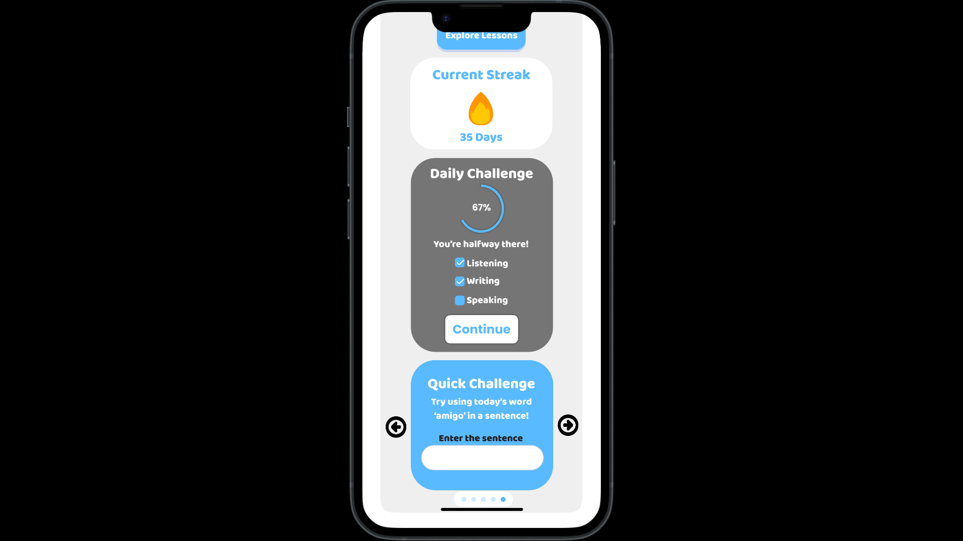

Each screen is designed with a clear flow and includes alternative color schemes to enhance user engagement and accessibility.

**Analysis:**

|  |  |
| --- | --- |
| **Name of the pattern/model** | Annunciator Row |
| **Selection Criteria** | Ensures users are always aware of essential device status like battery level, time, and network connectivity without disrupting the app experience. |
| **Benefits of using the pattern/model** | Improves usability by keeping critical information visible, allowing users to remain engaged in the app without needing to leave for device status checks. |
| **Conclusion** | The Annunciator Row enhances the overall app experience by providing seamless access to device information, supporting uninterrupted learning. |

|  |  |
| --- | --- |
| **Name of the pattern/model** | Revealable Menu |
| **Selection Criteria** | Provides efficient lateral access to main app sections (e.g., Learn, Stories, Dictionary) through a hamburger icon, reducing the need for backtracking. |
| **Benefits of using the pattern/model** | Streamlines navigation by allowing users to switch between sections with ease, improving the overall user journey within the app. |
| **Conclusion** | The Revealable Menu supports intuitive navigation, ensuring that users can access different parts of the app effortlessly, contributing to a cohesive experience. |

|  |  |
| --- | --- |
| **Name of the pattern/model** | Interstitial Screen |
| **Selection Criteria** | Engages users during onboarding by displaying progress updates between setup stages, adding a gamified element. |
| **Benefits of using the pattern/model** | Reinforces motivation through visual progress tracking, making the onboarding process feel rewarding and encouraging completion. |
| **Conclusion** | The Interstitial Screen adds a sense of achievement during onboarding, motivating users to stay engaged as they set up their profile and preferences. |

|  |  |
| --- | --- |
| **Name of the pattern/model** | Scroll |
| **Selection Criteria** | Allows users to scroll through content on the Home and Dashboard screens, making essential information accessible in a clean and organized way. |
| **Benefits of using the pattern/model** | Supports natural, intuitive browsing, ensuring that users can view multiple sections smoothly without overwhelming the screen. |
| **Conclusion** | Vertical Scroll improves the app's usability by providing a structured way to access content, maintaining clarity and simplicity in the interface. |

|  |  |
| --- | --- |
| **Name of the pattern/model** | Slideshow |
| **Selection Criteria** | Displays rotating, interactive content on the Home screen, like "Word of the Day" and "Quick Challenge," to encourage daily engagement. |
| **Benefits of using the pattern/model** | Keeps users engaged with new content each day, promoting regular app usage and reinforcing learning through varied, bite-sized information. |
| **Conclusion** | The Slideshow enhances engagement by delivering fresh, easily digestible content that encourages users to interact with the app consistently. |

**(Extend the table for all patterns/models you use)**

**Synthesis:**

**Explain the effect of the wireframes in your app’s usability.**

Standard patterns of navigation and engagement were used throughout its wireframes in order to make seamless the navigation in this application. The “Annunciator Row” keeps device status information available without interfering with the learning process, while the “Revealable Menu” allows for fast lateral access to other sections of the app, with only minimal backtracking required. The “Interstitial Screen” reinforces a feeling of achievement since, once taken through the setup process, there seems to be user advancement, and some sort of gamification involved, at all events, that essentially encourages. The vertical “Scroll” will enable smooth switching of sections both on Home and Dashboard screens, and the most natural and intuitive flow will hold the screen from clutter. This builds into the creation of a “Slideshow” on the Home screen for the photo content that will rotate daily phrases, quick challenges, and fun facts to help increase user engagement. Beyond just making information more digestible, this pattern of slideshow will allow for daily incentives in using the app and reinforce learning through regular interactions. The takeaway is that all these patterns work in synergy to create a non-intimidating, immersive experience that makes language learning both enjoyable and accessible.

**Figma Link:**

[**https://www.figma.com/design/HQikko0ouaB0IFihLg0vW5/Language-Learn-(Copy)?node-id=2143-4231&t=9MykJa2skOqs6Nyx-1**](https://www.figma.com/design/HQikko0ouaB0IFihLg0vW5/Language-Learn-(Copy)?node-id=2143-4231&t=9MykJa2skOqs6Nyx-1)